This term you could:
Find out as much as you can about magnetic materials.
Make a model or poster about reversible and irreversible changes.
Write a biography for a famous scientist.
Design an invention that uses filtering, sieving or evaporating.
Visit the Bristol museum to learn lots as a family including science facts about geology, minerals and animals!
Plan and do an investigation with an adult. Here are some ideas…
-Mix vinegar and bicarbonate of soda to make a model volcanic eruption.
-Freeze water. How long does it take?
-Heat up ice to melt it. What is happening?
Observe-
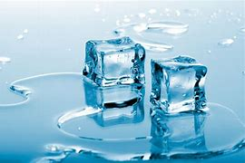
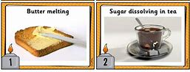
3. Ice melting

