What changed in Britain from the Stone Age to the Iron Age?
1 | When was the Stone Age and how did it begin?
2 | What was significant about the Stone Age?
3 | When was the Iron Age and how did it begin?
4 | What was significant about the Iron Age?
5 | What is the time between the two ages called and how was it significant?
6 | What events from the ages could you show on a timeline?
7 | What questions could you ask and how could you find them out using a range of sources?
8 | What different pencils could you use to draw and why?
9 | What are the skills you need for sketching?
10 | How do you use a pencil to show light and shadow, tone and texture?
Interesting facts
1 | Some of the oldest cave paintings are around 40,000 years old.
2 | The oldest musical instrument found is around 35,000-40,000 years old
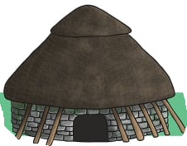
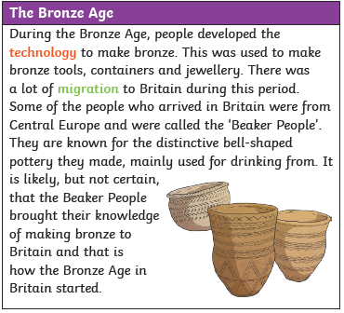
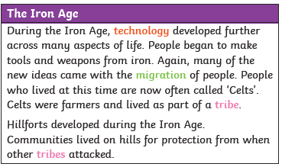
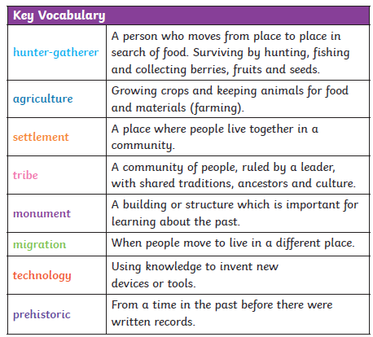
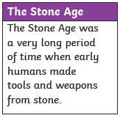
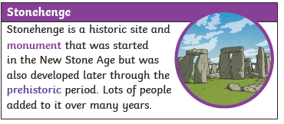
Stone Age House

