What did homes look like in the past?
Autumn, Term 1, - homework Options
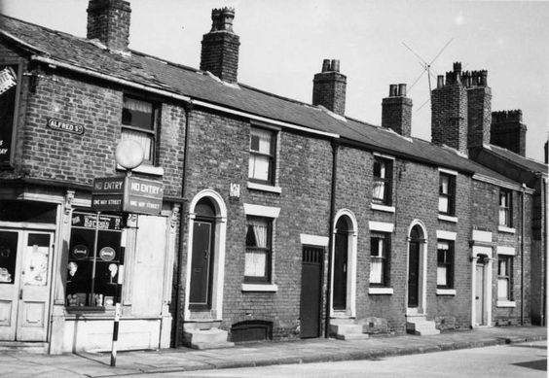
- Create a picture of your home. You could paint it, use just pencil or add colour using felt tips or colouring pencils. Try to include lots of detail.
- Draw a birds eye view of your bedroom. Here’s one to help get you started.
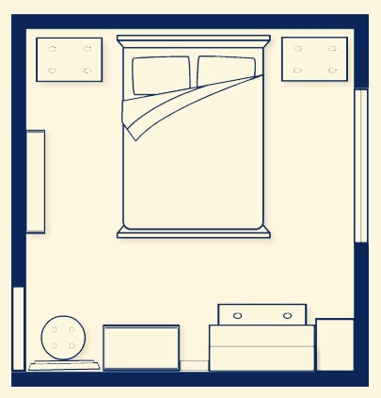
- Do some research on Corsham Court and find out whose home it used to be.
- Make a model of a home. It could be yours, someone from a book (like a castle or a cottage) or just one you would like to live in.
- Write a story about a little girl or little boy who lives in an underground home in a forest and who is friends with the animals that live there.

