Changes in Britain from the Stone Age to the Iron Age | What changed in Britain from the Stone Age to the Iron Age?
- When was the Stone Age and how did it begin?
- What was significant about the Stone Age?
- When was the Iron Age and how did it begin?
- What was significant about the Iron Age?
- What is the time between the two ages called and how was it significant?
- What events from the ages could you show on a timeline?
- What questions could you ask and how could you find them out using a range of sources?
- What different pencils could you use to draw and why?
- What are the skills you need for sketching?
- How do you use a pencil to show light and shadow, tone and texture?

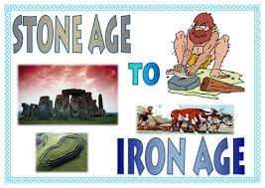

Related Milestones:
History M2:
• Place events, artefacts and historical figures on a time line using dates. • Understand the concept of change over time, representing this, along with evidence, on a time line. • Use dates and terms to describe events • Use appropriate historical vocabulary to communicate, including: • dates • time period • era • change • chronology. • Use literacy, numeracy and computing skills to a good standard in order to communicate information about the past. • Use evidence to ask questions and find answers to questions about the past. • Suggest suitable sources of evidence for historical enquiries. • Use more than one source of evidence for historical enquiry in order to gain a more accurate understanding of history.
Art – Drawing M:
• Use different hardnesses of pencils to show line, tone and texture. • Annotate sketches to explain and elaborate ideas. • Sketch lightly (no need to use a rubber to correct mistakes). • Use shading to show light and shadow. • Use hatching and cross hatching to show tone and texture.

