Autumn 1
Chatter Topics for
Turner Class

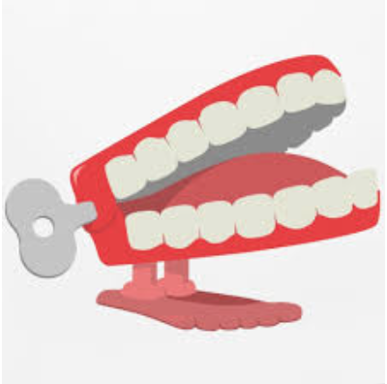
Chatter topic 1:
Why is learning about the past important?
Chatter topic 2:
Would you prefer to be a child now or in Anglo-Saxon times?

