What do plants need to grow?
Summer, Term 2, - homework Options
- Do an observational drawing of a plant or flower
- Collect some different leaves and see if you can find out what sort of tree they come from using this poster.
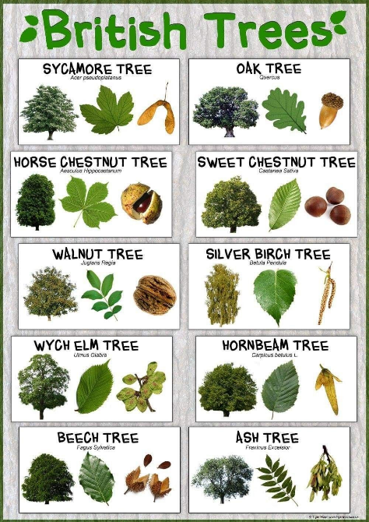
- Plants some seeds and watch them grown – can you keep a diary and draw them to show how they change?
- Make a game of flower snap.
- Write a story about a little girl or a little boy who discover a secret, walled garden in Corsham Park.

