What do plants need to grow?
Summer, Term 2
Chatter topics

What types of plants to do you like best and why – flowers, trees, pot-plants, cactuses or maybe an other kind of plant?

If you were able to create a new type of rose, what colour would you choose and what would you call it?

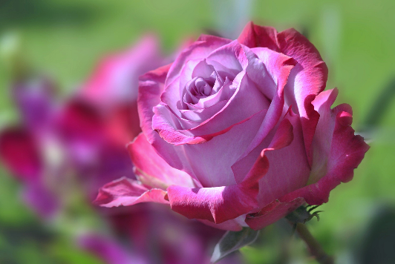

What would the world be like without plants? Could we survive without them?

What type of minibeasts might you find in Corsham Park? Think about ones that you might find in the water as well as on land.

