Summer 2
Chatter Topics for
Turner Class

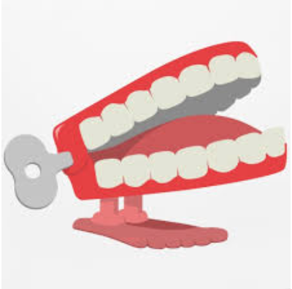
Chatter topic 1:
Typically, how do insects help plants reproduce?
Chatter topic 2:
What type of human behaviour would have a positive impact on the local wildlife?
Chatter topic 3:
Why are gardeners asked not to mow in May?

