Skills and Knowledge
Knowledge Organiser: What are maps and how do we use them? Term: 5 Year group: 1/2
 | Question | Answer
1 | What are the different compass points? | North, South, East, West,  North-West, South-West, North-East, South-East
2 | Why does a map need a key? | It contains an explanation of what the different lines and symbols on the map mean.
3 | Why does a map use grid references? | Grid references are used to locate a particular square on a map. It is a way to help us describe where something is on a map.
4 | What locational language can you use to describe the position of a feature on a map? | Next to, in front of, behind, North, South, East, West, North-West, South-West, North-East, South-East
5 | What locational language can you use to describe the position of a feature on a map? | Next to, in front of, behind. North, South, East, West, North-West, South-West, North-East, South-East
6 | Can you make a treasure map and add a key? | Using some of the symbols learnt this term and grid references, make a treasure map.
7 | Can you write a set of instructions for a recipe? | Write a set of instructions for a Pirate Treasure Salad
8 | Can you follow a set of instructions for a recipe? | Make a Pirate Treasure Salad, using instructions written previously
9 | What do we use to cut/peel/grate ingredients safely and hygienically? | We must use child-safe knives, graters and peelers, remembering to wash our hands before use and keeping our fingers away from sharp blades.
10 | How do we weigh or measure ingredients? | We use weighing scales to weigh out ingredients. The unit of measure is grams. Weighing scales can be digital or analogue.. We also use teaspoons and tablespoons to measure out ingredients.
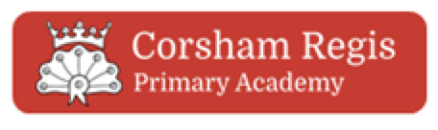
Key Vocabulary
 | Word | Definition
1 | Sketch map | A basic map with only basic detail
2 | Key | Helps us understand map symbols.
3 | Compass | A tool which shows people which direction they are travelling in.
4 | Route | A way of getting from a start point to a finish point.
5 | Map symbol | A picture or a sign on a map that represents something else.

Interesting facts
1 | A map maker is called a cartographer.
2 | The oldest maps were made on clay tablets.
