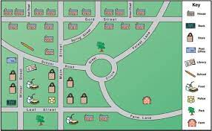

Homework Options
- Draw a map of your bedroom, from a birds eye view.
- Make your own Treasure map.
- Design a healthy meal for a pirate.
- Make a game of map symbol snap.
- Write some directions for a grown up to follow, using forwards, backwards, left, right and turns.
- Write a set of instructions for making a simple meal.
- Have a go at making your meal, with a grown up.

