Home learning in Fox

In order to help your child learn, we encourage you to read with your child daily. This is to practise reading skills, comprehension and reading for pleasure. We would like you to spend time supporting your child to learn to read and spell the statutory words for Years 1. You could concentrate on 5 of these at a time. These are available on our website. Please ask your child about the maths that they are completing in class and practise number bonds.

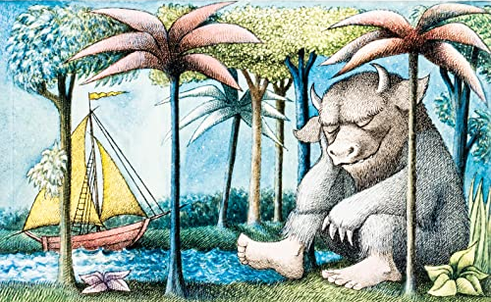

In addition to this we have some optional home learning linked to our topic this term, which is ‘how are places different’. If you would like to help your child with our topic this term below are some ideas:

- Make a messy map of your house and label it
- Map your route to school, what do you pass?
- Write a list of things you might need for an adventure
- Design your own island for your own adventure
- Create your own compass
- Retell the story of ‘We’re Going on a Bear Hunt’ or ‘Where the Wild Things Are’ to someone at home.

