Geography and DT | How did we navigate in a pre-digital world?
- What four things can you use to read a map?
- How can you use a map to communicate your knowledge of the UK and wider world?
- How can you make your own map of a location?
- What do you need to identify on your map?
- How can you represent a location using different types of maps?
- Why might some map types be better than others?
- Why is it important to store and handle ingredients correctly?
- How do you measure ingredients accurately and scale recipes to feed more or less people?
- What are the different ways of cooking something?
- How would you create your own recipe?
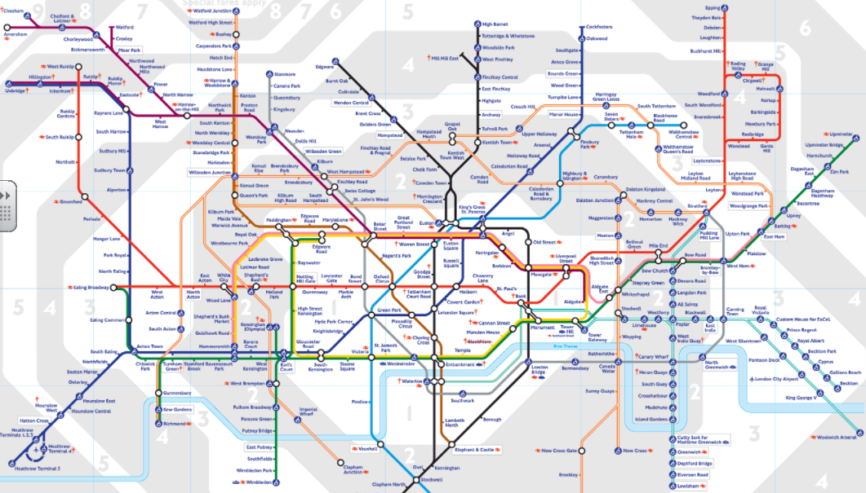
Related milestones:

Geog M3:

• Use the eight points of a compass, four-figure grid references, symbols and a key (that uses standard Ordnance Survey symbols) to communicate knowledge of the United Kingdom and the world. • Create maps of locations identifying patterns (such as: land use, climate zones, population densities, height of land). • Analyse and give views on the effectiveness of different geographical representations of a location (such as aerial images compared with maps and topological maps - as in London’s Tube map).

DT M3:
Food • Understand the importance of correct storage and handling of ingredients (using knowledge of micro-organisms). • Measure accurately and calculate ratios of ingredients to scale up or down from a recipe. • Demonstrate a range of baking and cooking techniques. • Create and refine recipes, including ingredients, methods, cooking times and temperatures.

