Geography and DT | What are maps and how do we use them?
1.What are the different compass points?

2.Why does a map need a key?

3.Why does a map use grid references?

4.What locational language can you use to describe the position of a feature on a map?

5.Can you make a treasure map and add a key?

6.Can you write a set of instructions for a recipe?

7.Can you follow a set of instructions for a recipe?

8.What do we use to cut/peel/grate ingredients safely and hygienically?

9.How do we weigh or measure ingredients?

10.What do we use to cook our food?
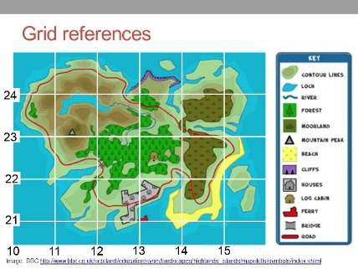

Related milestones:
Geog M1:
• Use compass directions (north, south, east and west) and locational language (e.g. near and far) to describe the location of features and routes on a map. • Devise a simple map; and use and construct basic symbols in a key. Use simple grid references (A1, B1)
DT M1:
Food • Cut, peel or grate ingredients safely and hygienically. • Measure or weigh using measuring cups or electronic scales. • Assemble or cook ingredients

