Summer 5
Chatter Topics for
Turner Class

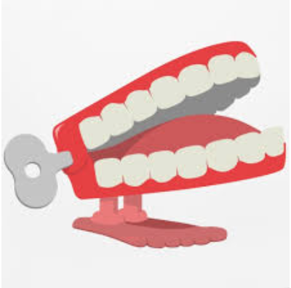

Chatter topic 1:
Who was pirate Blackbeard?
Chatter topic 2:
Are there still pirates?
Chatter topic 3:

Why did pirates have parrots - can you think of the funniest reason?

