Summer 5 Chatter Topics for
Fox Class

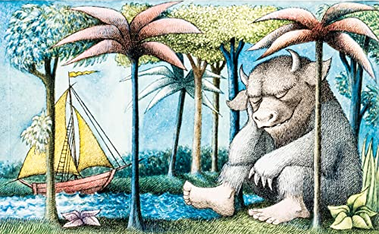

- If you could land on any make believe island, where would you land?
- What would you find on your magical island?
- What can you see on the map of your island?
- What might happen in your adventure?
- Who would you take with you on your journey?

