Skills and Knowledge
Knowledge Organiser: Where are the hottest countries in the world? Term: Spring 4 Year group: 1/2
 | Question | Answer
1 | Where is the United Kingdom on a map/atlas/globe? | The United Kingdom is an island which lies in Western Europe in the Atlantic Ocean.  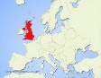
2 | What are the names of the continents and seas/oceans of the world? | The continents of the world are – Asia, Africa, North and South America, Antarctica, Europe and Australia.  The oceans of the world are - Atlantic, Pacific, Indian, Arctic and Southern.
3 | Why does the weather change throughout the year in the United Kingdom? | The United Kingdom is in a part of the world where warm air from the South mixes with cold air from the North and this gives it a very changeable weather and climate.  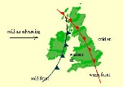
4 | Where is Kenya? Can you locate it on a globe/map? | Kenya is located in the North East of Africa and it’s coast lies on the Indian Ocean.  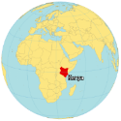
5 | What is the weather like in Kenya? | Kenya has a hot climate but there are two wet seasons and two dry seasons over the course of the year.
6 | What are some of the geographical similarities between the United Kingdom and Kenya? | The United Kingdom and Kenya both have coasts which boarder oceans. They both have a varied landscape, ranging from flat land to mountainous areas.  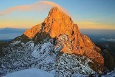
7 | What are some of the geographical differences between the United Kingdom and Kenya? | Kenya is more than twice the size of the United Kingdom but around 11,000,000 less people live there. It has a much hotter climate with wet and dry seasons, compared to the four seasons of the United Kingdom.
8 | What is life like in Kenya? | Most Kenyan people live in rural areas and depend on agriculture for a living. Life in some these areas can be very poor and poverty and disease means people live hard lives.
9 | Why is it so cold in Antarctica? | Antarctica surrounds the South Pole and gets very little sunlight, It is covered in snow and ice all year.  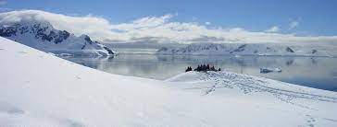
10 | What is life like in Antarctica? | It is completely dark for many months of the year in Antarctica. There are no native people from this continent and the only population is from people living on research stations.
Key Vocabulary
 | Word | Definition
1 | atlas | A book of maps or charts.
2 | continent | One of the worlds continuous pieces of land.
3 | ocean | A large expanse of sea.
4 | climate | The weather conditions in a certain area.
5 | globe | A spherical model of the Earth.

Interesting facts
1 | There are over 60 different languages spoken in Kenya.
2 | Mount Kenya is the second highest mountain in Africa.
