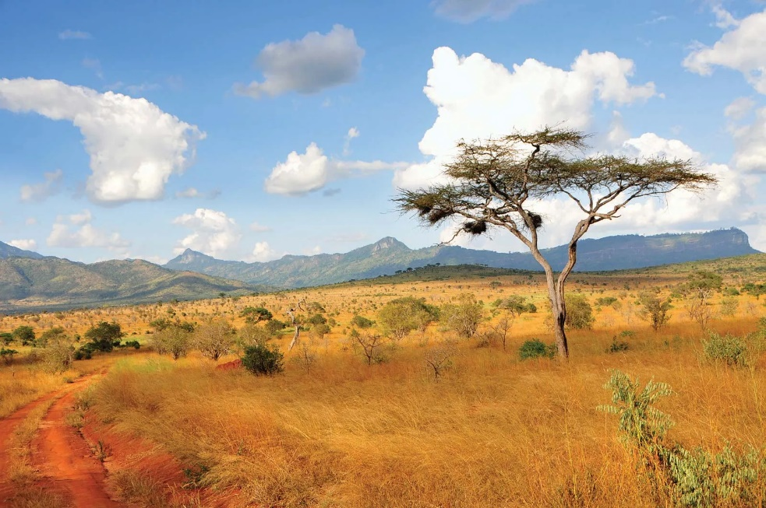

Homework Options
- Paint or draw a picture of an animal from a cold climate.
- Research and make a fact file all about one of the animals from Kenya.
- Keep a weather diary for a week.
- Kenya has lots of safari animals like elephants, giraffes, zebras and hippos. Can you make a model of one? You could use junk material, lego or maybe something else.

