Skills and Knowledge
 | Question | Answer
1 | Who was Vincent Van Gogh? | He was a Dutch painter who lived in the second part of the 1800s. After he died, he became recognised as one of the most famous artists ever.
2 | What were his most famous works of art? | The Potato Eaters  The Sunflowers – he painted 11 different versions of this.  The Starry Night  The Bedroom at Arles
3 | What inspired his paintings? | He was inspired by different artists and different subjects at different times in his life. To begin with, he wanted to become good at drawing. Then he began to use brighter, bolder colours like the artists he met in Paris. Eventually, his work became less realistic. He took inspiration from the people and landscapes around him and from nature.
4 | What did he use to create his works of art? | To draw, he used pencil, chalk, charcoal and pen.  To paint, he mainly used oil paints but also created 150 works using watercolours. He is famous for using thick paint and bold strokes.
5 | What could you use to create your art work? | You could use thick poster paints to recreate his style. You could also experiment with a variety of drawing materials.
6 | How could you take inspiration from Van Gogh to create a sculpture? | Look at a selection of his flower paintings. Can you create a sculpture of one of these flowers out of recycled materials?
7 | How could you use Van Gogh’s work and the work of other artists to make a print? | You could create a repeat of the image you painted with the poster paints, using a simple etching technique.
8 | How could you use collage to complement your art work? | We could create a frame for our print or painting using collage in similar colours.
9 | What makes a good singing performance? | We will learn about pitch, tone, breathing and enjoying the song .
10 | How could you make up your own song and use symbols to write it down? | We will use Van Gogh as the inspiration for our lyrics.
Key Vocabulary
 | Word | Definition
1 | Portrait | A painting, drawing, photograph or sculpture of a person.
2 | Landscape | A picture that shows a view of an area.
3 | Still life observational drawing | A drawing or painting from life.
4 | Oil paints | A thick paint made with ground pigment and a drying oil, like linseed oil.
5 | Post-Impressionists | The name for artists like Van Gogh, who used bright colours and symbols to show emotions and feelings in their art work.
Interesting facts
1 | Van Gogh also wrote many letters during his life. | He wrote nearly 800 letters, mainly to his brother, Theo.
2 | He only sold one painting during his lifetime. | Although he created over 2,000 paintings and drawings, it was only after he died that people began to buy them.
Useful pictures/diagrams

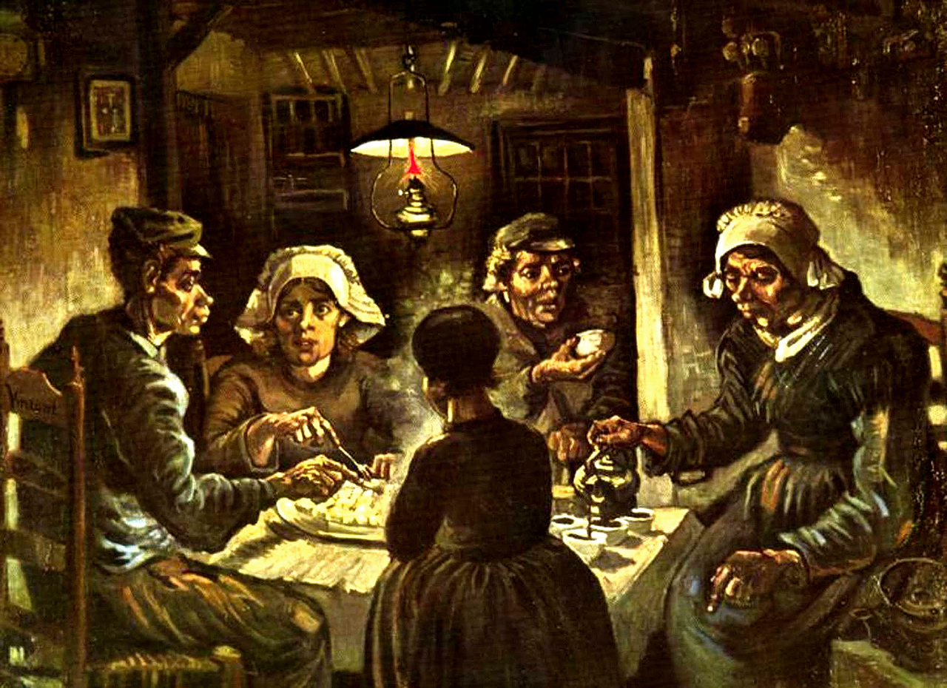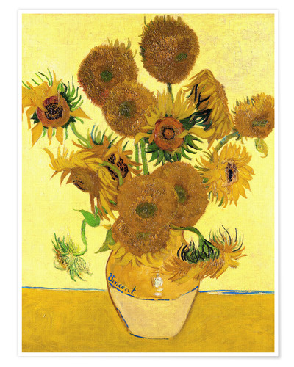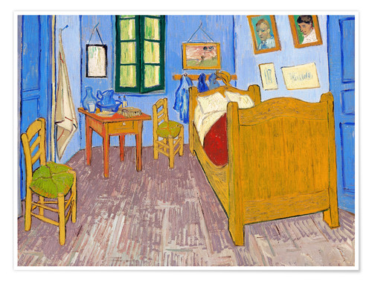
The Potato Eaters The Sunflowers The Bedroom at Arles

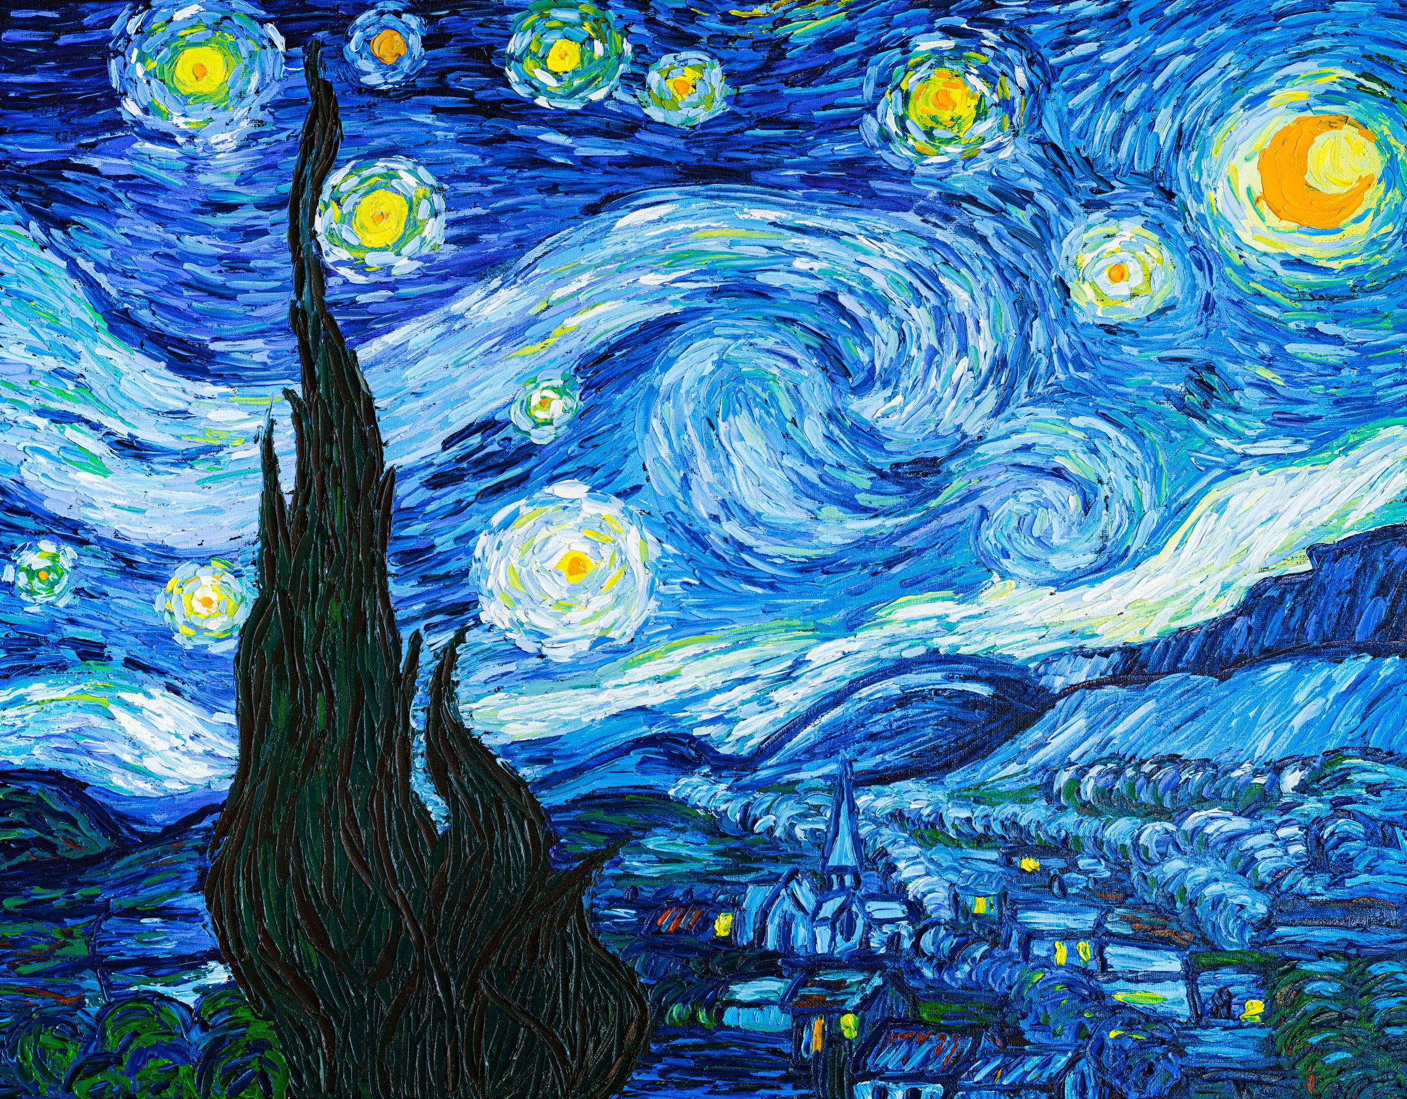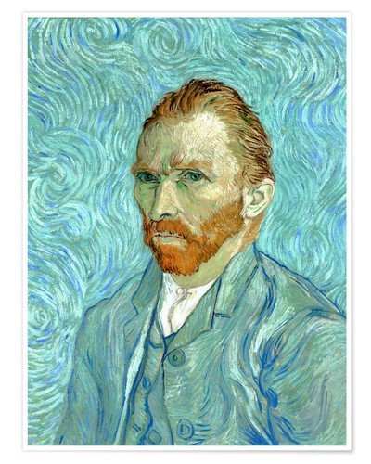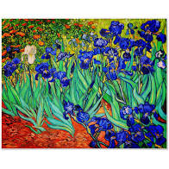
The Starry Night Self Portrait Irises

Knowledge Organiser for: Arts Term: 5 Year group: 1/2

