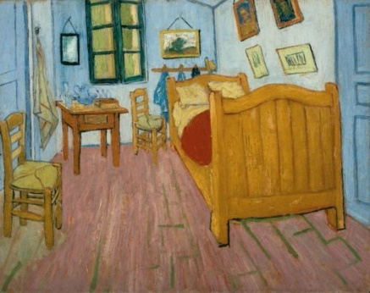
Chatter topics
- How was Van Gogh’s bedroom different to your bedroom?
- Look at two of Van Gogh’s Sunflower paintings and discuss what is the same and what is different about them.
- Which of Van Gogh’s paintings is your favourite? Why?
- What things do you think Van Gogh enjoyed painting most? What makes you think this?
- Would you like to be one of the people in The Potato Eaters? Explain why you would or wouldn’t.

