Home learning in Fox

In order to help your child learn, we encourage you to read with your child daily. This is to practise reading skills, comprehension and reading for pleasure. We would like you to spend time supporting your child to learn to read and spell the statutory words for Years 1. You could concentrate on 5 of these at a time. These are available on our website. Please ask your child about the maths that they are completing in class and practise number bonds.

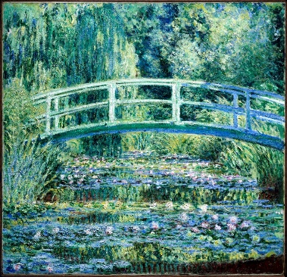

In addition to this we have some optional home learning linked to our topic this term, which is ‘Take one picture’ If you would like to help your child with our topic this term below are some ideas:

- Research some of Claude Monet’s other paintings
- Create your own Claude Monet painting
- Construct a garden like Monet’s out of Lego or natural objects
- Create a bunch of flowers out of paper and straws
- Construct a bridge that will take the weight of a potato
- Retell the story of ‘Katie and the Waterlily pond’ to someone at home.

