The Arts | Take One Picture
- What is an artist?
- Who was Claude Monet?
- Which is your favourite Monet painting and why?
- What do Monet’s paintings look like and how could you paint like him?
- What different media could you use to create a piece of art work?
- What is a sculpture and what could you use to make one?
- What is a print and how could you create your own?
- How do you collage?
- What makes a good singing performance?
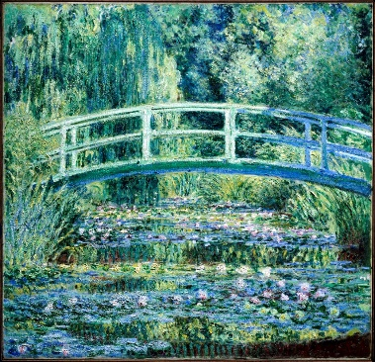
- How could you make up your own song and use symbols the write it down?

Related Milestones:

Art M1:
To develop ideas • Explore ideas and collect visual information. SCULPTURE- TECHNIQUES • Use a combination of shapes. • Include lines and texture. • Use rolled up paper, straws, paper, card and clay as materials. • Use techniques such as rolling, cutting, moulding and carving.
To develop ideas• Respond to ideas and starting points. PRINT- TECHNIQUES • Use repeating or overlapping shapes. • Mimic print from the environment (e.g. wallpapers). • Use objects to create prints (e.g. Fruit, vegetables or sponges). • Press, roll, rub and stamp to make prints.
To develop ideas • Explore ideas and collect visual information. TO TAKE INSPIRATION FROM THE GREATS (CLASSIC AND MODERN) • Describe the work of notable artists, artisans and designers. • Use some of the ideas of artists studied to create pieces.
PAINTING- TECHNIQUES • Use thick and thin brushes. • Mix primary colours to make secondary. • Add white to colours to make tints and black to colours to make tones. • Create colour wheels.
COLLAGE • Use a combination of materials that are cut, torn and glued. • Sort and arrange materials. • Mix materials to create texture.
To develop ideas • Explore different methods and materials as ideas develop DIGITAL MEDIA - TECHNIQUES • Use a wide range of tools to create different textures, lines, tones, colours and shapes.

Music M1:
To perform • Take part in singing, accurately following the melody. • Follow instructions on how and when to sing or play an instrument. • Make and control long and short sounds, using voice and instruments. • Imitate changes in pitch. To describe music • Identify the beat of a tune. • Recognise changes in timbre, dynamics and pitch.
To compose music • Create a sequence of long and short sounds. • Clap rhythms. • Create a mixture of different sounds (long and short, loud and quiet, high and low). • Choose sounds to create an effect. • Sequence sounds to create an overall effect. • Create short, musical patterns. • Create short, rhythmic phrases.
To transcribe • Use symbols to represent a composition and use them to help with a performance.

