Spring 3 Chatter Topics for
Fox Class

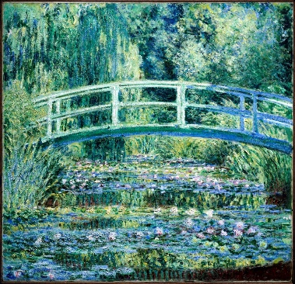

- What is an artist?
- What can you see in this picture? (Play I-spy with an adult).
- What creatures and wildlife might you see in this picture?
- What title would you give this piece of art and why?
- What colours did the artist use to create this painting?

