Skills and Knowledge- How do we see and hear?
 | Question | Answer
1 | What is reflection | Reflection is when a light from an object is reflected by a surface and it changes direction. It bounces off the surface in the same direction as it hits.  Smooth, shiny surfaces reflect light well..
2 | How is a shadow made? | A shadow forms when an opaque object blocks light from passing through.
3 | How does light travel and how does that help us see? | Light travels in waves and light waves travel in straight lines. Light travels form light sources to our eyes.
4 | How does vibration create sound? | When any sort of object vibrates it causes particles to move. The vibrations enter your ear and you hear them as sounds.
5 | What is volume and how does the volume of sound change, depending on how faraway something is? | The volume of a sound is how loud or quiet the sound is.  Sounds are vibrations that travels through the air; a strong vibration makes a loud sound and a weak vibrations makes a quiet sound.
6 | What is pitch? | The pitch of a sound is how high or low the sound is.
7 | What questions could you ask about light and sound and how could you find out the answers? | I could ask about how light travels and how light can be blocked. I can use books, online information and classroom resources to find my answers.
8 | What experiments could you do with light and sound and how could you report on your findings? | I find out about how light reflects and explore reflective surfaces. I could report which materials work best.  I could find out about what blocks shadows and suggest materials.  I could explore vibrations and record the volume of different instruments
9 | What skills do you need to make, repair or strengthen something? | I could explore repairing and strengthening something by using different materials.
10 | Which mechanisms could you use to make something move? | I could use a range of mechanisms such as levers, pulleys, fasteners, gears and springs.
Key Vocabulary
 | Word | Definition
1 | Light | A form of energy that travels in a wave from a source
2 | Light source | An object that makes its own light
3 | Dark | Dark is the absence of light
4 | Vibration | A quick movement back and forwards
5 | Amplitude | The size of the vibration  A larger amplitude means a louder sound.
6 | Volume | The loudness of a sound
Interesting facts
1 | It takes 8 minute and 20 seconds for light from the sun to reach the Earth.
2 | - Dogs can hear much higher sounds than humans and bats and dolphins can hear lower sounds than humans.  Useful pictures/diagrams  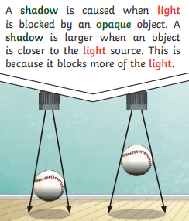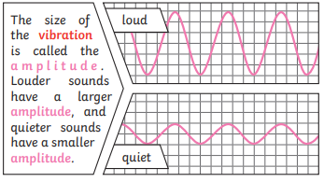
Knowledge Organiser for: Science and DT Term: 1 Autumn 2 Year group: 3/4

