Skills and Knowledge
Knowledge Organiser: Who Can You Make Out of Different Materials? Term: 2 Year group: 1/2
 | Question | Answer
1 | What are some names of some everyday materials? | Metal, plastic, wood, stone, fabric, ceramic, rubber, brick, glass, leather.
2 | How can I distinguish between an object and the material it is made from? | 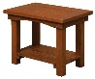  E.g. A table is an object and it is made from wood and metal.
3 | What words can we use to describe the properties of some everyday materials? | Hard, soft, rough, smooth, thick, thin, opaque, transparent, translucent, absorbent, waterproof, rigid, flexible.
4 | How can materials be compared and grouped, based on their physical properties? | Materials can be grouped and compared according to their properties. They can be grouped into hard/soft, rough/smooth, waterproof/absorbent, opaque/transparent/translucent.
5 | How can materials be changed? | 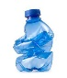  Some materials can be squashed, squeezed, bent, twisted or stretched.
6 | What are some everyday materials used for? | 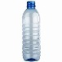  Plastic is used to make…Glass is used to make… Metal is used to make …..
7 | Which materials are suitable for different purposes? | Metal is used to make…because it is strong, rigid and opaque.
8 | Can I design a product which will use suitable materials? | 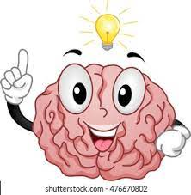  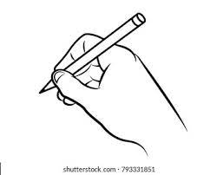  I will use the materials…  These will be suitable because…
9 | Can I make a product using suitable materials? | 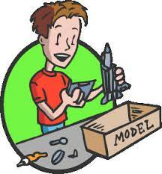  I will choose appropriate materials to make my design.
10 | Can I cut and join materials using a range of techniques? | I will use a range of techniques and equipment to make my design. I will see which technique works the best.
Key Vocabulary
 | Word | Definition
1 | material | What an object is made from.
2 | opaque | You can not see through it.
3 | transparent | You can see through it.
4 | rigid | You can not change its shape.
5 | flexible | You can change its shape by bending or stretching.

Interesting facts
1 | Glass is actually made from sand!
2 | 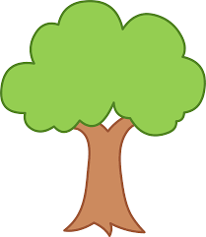  Paper comes from trees!

