Home learning in Fox

In order to help your child learn, we encourage you to read with your child daily. This is to practise reading skills, comprehension and reading for pleasure. We would like you to spend time supporting your child to learn to read and spell the statutory words for Years 1. You could concentrate on 5 of these at a time. These are available on our website. Please ask your child about the maths that they are completing in class and practise number bonds.

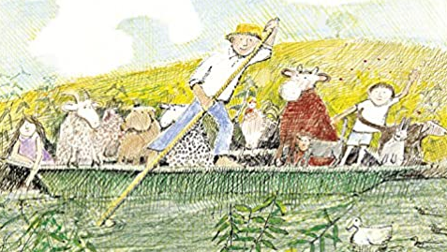

In addition to this we have some optional home learning linked to our big question this term, which is ‘What can a boat be made of?’ If you would like to help your child with our topic this term below are some ideas:

- Have a go at constructing a boat for Mr Gumpy and his friends out of Lego or cardboard boxes
- Does your boat float or sink?
- Create a picture of Mr Gumpy and his friends
- Go for a material hunt around your house, what different materials can you find?
- Collect some objects from around your house then see if they float or sink
- Retell the story of ‘Mr Gumpy’s outing’ to someone at home.

