Everyday Materials | What can a boat be made out of?
- How can you change the shapes of solid objects, by squashing, bending, twisting and stretching?
- What everyday objects are made from wood, metal, plastic, glass, brick and paper?
- What questions could you ask to find out about materials?
- How could you sort different materials?
- What tests could you do with different materials and what equipment would you need?
- How could you use what you see to answer your questions?
- How could you collect the information from your tests?
- What could you make from drilling, screwing, gluing and nailing?
- What could you make from levers, wheels and winding?
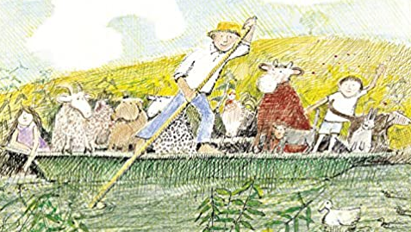
- How could a low battery or damage stop something from working?

Related Milestones:
Science M1:
To investigate materials • Find out how the shapes of solid objects made from some materials can be changed by squashing, bending, twisting and stretching • Identify and compare the uses of a variety of everyday materials, including wood, metal, plastic, glass, brick/rock, and paper/cardboard.
To work scientifically • Ask simple questions • Identify and classify • Perform simple tests • Observe closely, using simple equipment • Use observations and ideas to suggest answers to questions • Gather and record data to help in answering questions.
DT M1:
Construction • Use materials to practise drilling, screwing, gluing and nailing materials to make and strengthen products.
Mechanics • Create products using levers, wheels and winding mechanisms
Electricals and electronics • Diagnose faults in battery operated devices (such as low battery, water damage or battery terminal damage)

