Autumn 2
Chatter Topics for
Turner Class

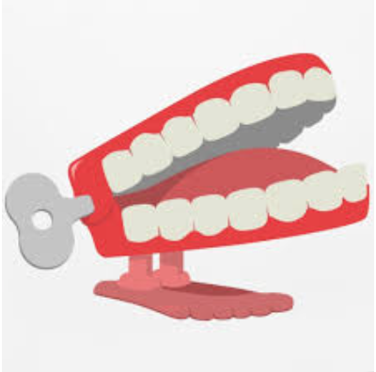
Chatter topic 1: Who was the second person to land on the moon?
Chatter topic 2: What animals have been into space?
Chatter topic 3: Can a star turn into a planet?

Chatter topic 4: Does sound travel faster in space?

Chatter topic 5: Have aliens ever visited earth?

