Autumn 2
What can you make out of different materials?
Chatter Topics for
Dickens Class

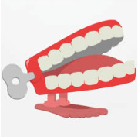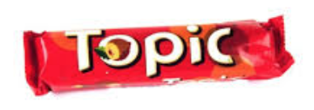
Chatter topic 1: Glass has been used to create unusual things such as stairs and tables. What unusual thing would you design made out of glass and why did you choose this item?
Chatter topic 2: Which material do you think is the most important one used in our world today?
Chatter topic 3: What was life like before plastic was invented? Which things that are made out of plastic would you miss most?

Chatter topic 4: What is your favourite toy made out of wood? Why do you like it and why is wood such a good material for it to be made from?

