Autumn 2 Chatter Topics for
Fox Class

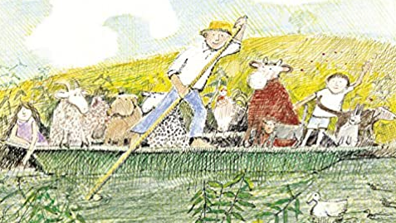

- Who would you invite in your boat for a trip and why?
- Where would you go on a boat trip?
- What creatures and wildlife might swim under or around your boat?
- What places do you think you would pass on your boat trip?
- What materials could your boat be made out of?

