Autumn 1 Chatter Topics for
Fox Class

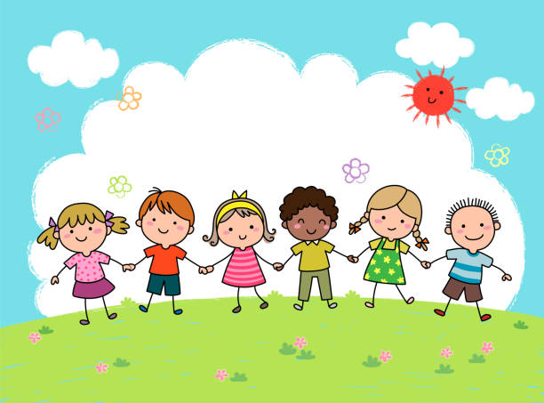

- What makes you special?
- Who is special to you in your family?
- What makes you happy?
- What makes a good friend?
- Can you describe your friend and explain why you like them?
- How are you similar to your friends?
- How are you different from your friends?
- Can you recite where you live?
- Do you live near any of your friends?

