If you are able to take photos of your homework and bring them in or send them to us via SeeSaw, we would love to see what you have done.

Who was Isambard Kingdom Brunel and why was he important?
 | Homework Options
Task 1 | Use the internet the find some information about Brunel.
Task 2 | Draw a picture of Brunel.  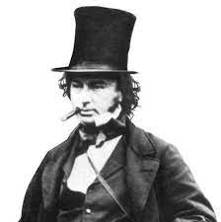
Task 3 | Build a bridge using lego, junk recycling, blocks or anything else you have at home.
Task 4 | Design a new logo for the Great Western Railway line.
Task 5 | Look at this picture of a Victorian kitchen. How is it different to your kitchen at home.  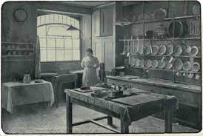
Task 6 | Find out what schools were like in the Victorian times.

