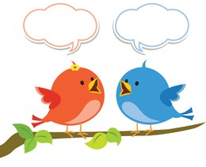
Mason and Millward Class Chatter Topics

- Why do we have teeth??
- What would happen if our bones were bendy?
- What would we do if toothbrushes didn’t exist?
- What would happen if we didn’t exercise?
- What happen if we only ate chips?
- What if there were no insects?
- How many vegetables should I eat in a day?
- Which foods keep us healthy?
- Why do animals eat different things?
10. What helps us to move?

