

Kings Avenue

Corsham   
 Wiltshire

SN13 0EG

Tel No: 01249 712294

Email: admin@corshamregis.wilts.sch.uk

Web Site: [www.corshamregis.wilts.sch.uk](http://www.corshamregis.wilts.sch.uk)

Headteacher Mrs A Symons

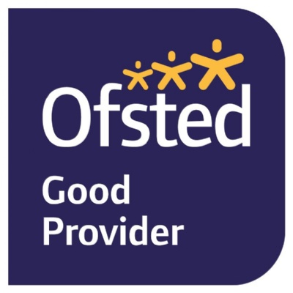

# **Why do teachers set Home Learning at Corsham Regis?**

Learning at home is an essential part of good education and it is a time when children can apply the knowledge they have learnt at school. It also encourages children to become confident and independent in their learning, which will help throughout their time at school and later in adult life.

# **What help are parents and carers expected to give?**

We would like you to focus on the basics: **reading**, **spelling** and **mental maths**. Spend time with your child enjoying books, learning to read and spell new words and becoming fluent in mental maths skills. There are no set time limits for completing this type of Home Learning.

We would like you to engage in conversations with your child about what they have been learning about in school and support them in completing **home learning based on their current topic,** which you can find on the class of pages of our website.

# **Home Learning in Foundation Stage**

Reading to your child will help to develop a love of reading. This enjoyment will encourage children to pick up story books and want to read to an adult at home. We recommend that children read or hear an adult read every day at home- even if it’s just for 5 minutes.

We would like you to encourage your child to use the time after school for unstructured play – developing their own creativity.

# **Home Learning in Years 1 to 6**

We would encourage you to **read** with your child daily. This is to practise reading skills, comprehension and reading for pleasure.

We would like you to spend time supporting your child to learn to **read** and **spell** the statutory words for their year group. You could concentrate on 5-10 of these at a time. These are given out at the beginning of the academic year and are available on our website.

Children should also begin to learn their **times tables** as they are expected to know them all by the time they reach the end of Year 4.

In the Spring and Summer terms **in Year 6, revision** and **practise** for the end of Key Stage 2 assessments will form the main part of Home Learning. It is important that these are completed at home to develop your child’s confidence in lessons.

# **Recording Reading**

Please complete the reading record that will be sent home with your child every time that they engage in reading.

# **Optional Extras for Years 1-6**

There will also be a list of ‘Chatter Topics’ and extra- curricular activities linked to the topic being taught that you may want to complete with your child. The ‘Chatter Topics’ will give you some ideas for talks you could have with your child about what they are learning in school. You could chat about these around the dinner table or in the car.

We value the importance of learning together as a family. Teachers will give you some ideas of how you could take part in extra-curricular activities to further develop your child’s learning experiences. This could involve a trip to a museum, park, zoo or joining an extra-curricular sports club.

If you complete any of these activities, please let the class teacher know so that we can celebrate your child’s successes in school.

# **Where can I find out more?**

If you need more information about your child’s home learning, please visit our school website and your child’s class page. You will find information about reading, spelling, maths and the optional projects. If you wish to complete further Home Learning, there will be links to useful websites to support learning.

Thank you for your support