Summer 2 – What keeps us alive?

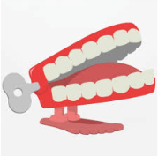

Chatter topic 1: What do we need to do to stay healthy?
Chatter topic 2: What are your 3 favourite ways to keep fit and active – do you prefer games, sports or keeping fit by doing things like walking, cycling and activities you do just for fun.
Chatter topic 3: What can you do to look after your mental health?

Chatter topic 4: If you were the Prime Minster, what foods would you encourage people not to eat because they are unhealthy?

