Kings Avenue

Corsham   
 Wiltshire

SN13 0EG

Tel No: 01249 712294

Email: admin@corshamregis.wilts.sch.uk

Web Site: [www.corshamregis.wilts.sch.uk](http://www.corshamregis.wilts.sch.uk)

Headteacher Mrs A Symons



**ATTENDANCE IS IMPORTANT**

Dear Parents/ Carers,

In order for children to learn and make expected and better progress it is essential that their attendance at school remains good. Our target for attendance is 96% for all children. We do not expect children to come to school when they are poorly but we hope to eliminate the casual absences for things such as Birthdays, tiredness and sore throats that may not exist!

Missed school not only affects your child’s academic progress but it also affects their ability to build relationships with their peers, develop social interaction skills, affects their overall wellbeing and disrupts routines. If a child is persistently off school, then it becomes a safeguarding concern and the safety of all our children is a priority.

If we are concerned about your child’s attendance, you will receive a letter and if it continues to remain a concern, we will take the appropriate actions and this can ultimately lead to fines being issued.

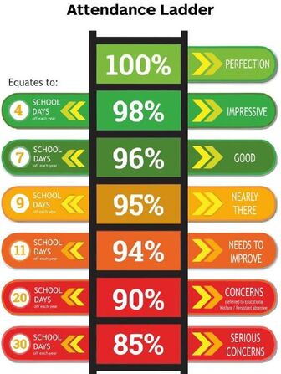

**Term time Holidays and Lateness**

Following Government guidelines, the academy **DOES NOT** approve of taking time off during term time.

It is legal requirement for your child to attend school.

A request for time off will be given full consideration by the Headteacher, Mrs Abby Symons. Parents /Carers must fill out a Leave of absence request outlining their reasons for not attending school. Please ask Mrs Hunt for one of these at the main office.

A statutory fine will be enforced if unauthorized time off reaches 10 sessions (5 days) in a six-month period.

You will also be fined if your child is late on 10 or more occasions within a six-month period.

**Illness**

We are aware that at times children are ill and, therefore, should not come to school.

Pupils who have had any type of sickness or diarrhea **MUST NOT** be at school until they have been symptom free for 48 hours.

Please ensure that you report your child absent to the school’s office on the **FIRST** morning by 9.10am.

Parents/Carers should try and arrange medical appointments outside of school time and are requested to confirm in writing the reason for the planned absence, the time of leaving and the expected time of return.

The teachers and staff are committed to providing pupils with the very best schooling at all times but the responsibility of ensuring children attend school is that of the parents/Carers.

**In school** we celebrate good attendance and have devised a number of incentives:

1. 100% attendance during the course of a week=child’s name entered into **‘IN TO WIN’** game, names pulled out of a hat during Friday celebration assembly, chosen child chooses a treat and all children receive a sticker/ certificate.
2. 100% attendance for half a term= entry into the **‘100 Club’** and given a treat as a group.
3. Termly (x3) children with 100% attendance get to invite a special person to join them for a **treat in school,** tea party, board games afternoon etc. (activity to be decided by the School council).

The class with the highest weekly attendance get to have S.A.M (School Attendance Mascot) the sloth, in their classroom for the week to look after.

I hope that together we can work to achieve our end goal of 96%.

Yours sincerely

Abby Symons

Headteacher