Events Beyond Living Memory – Significant Locally/Globally | What happened before I was born?
- What does ‘nation’ mean?
- What are some significant events in our national history?
- What are some significant events in our global history?
- How could you describe simple historical words?
- How could you cut/shape different materials safely?
- How do you measure something accurately?
- How do you join different materials?
- What product could you make for a specific reason or person?
- How could you make your product better?
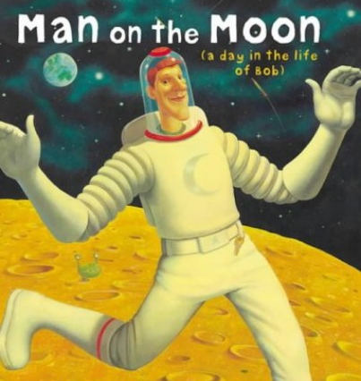
- How could you use a computer to design your product?

Related Milestones:
Hist M1:
• Show an understanding of the concept of nation and a nation’s history. • Show an understanding of concepts such as civilisation, monarchy, parliament, democracy, and war and peace.

DT M1:
Materials • Cut materials safely using tools provided. • Measure and mark out to the nearest centimetre. • Demonstrate a range of cutting and shaping techniques (such as tearing, cutting, folding and curling). • Demonstrate a range of joining techniques (such as gluing, hinges or combining materials to strengthen).
To design, make, evaluate and improve • Design products that have a clear purpose and an intended user. • Make products, refining the design as work progresses. • Use software to design.

