Summer 1 - What did the Romans leave behind in Bath?

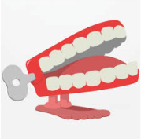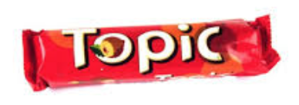
Chatter topic 1: Look at this picture of Romans bathing in the hot baths. What would be your favourite part of a visit there - the massage, the cold baths, the hot baths, the socialising with friends or maybe something else?
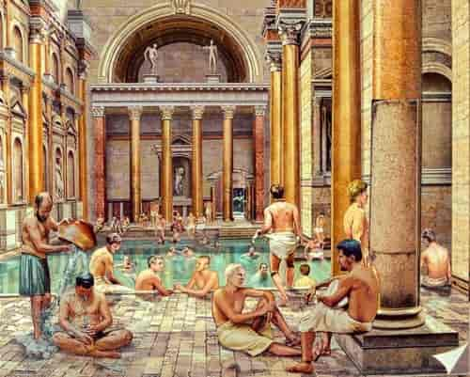

Chatter topic 2: If someone from Roman came to Corsham today, what would you tell them about our town? What do you think they would like to see and do?
Chatter topic 3: If the Romans hadn’t come to Britain, how do you think life would be different now? What things might we not have – or do you think someone else would have invented them?

Chatter topic 4: Would you like to have been a Roman Emperor? What do you think would have been good and bad about doing the job?

