Summer 5 Chatter Topics for
Fox Class

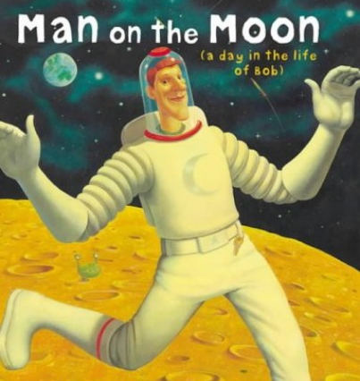

- What do you think you can see on the moon?
- How would you like to travel to the moon?
- How were nations effected by the moon landing and how did it bring nations together?
- What sort of moon landing party would you throw?
- What causes the moon to shine?
- What else happened before you were born?

