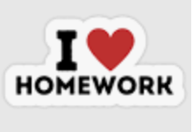
If you are able to take photos of your homework and bring them in or send them to us via SeeSaw, we would love to see what you have done.

 | Homework Options
Task 1 | Design and create a Roman shield. (You could research what designs were popular and use the card from a cereal box).
Task 2 | Create a poster advertising The Roman Baths as they would have been in the Roman era – remember that they used it as a place to relax and socialise as well as bath.
Task 3 | Do some research on the clothes that rich and poor Romans wore. Draw a picture of a rich Roman and a poor Roman, dressed as they would have been.
Task 4 | Look at some Roman mosaics. Can you create your own – you could create a picture by drawing tiny squares or cut up tiny squares from different coloured paper to do it.
Task 5 | Draw a picture of a Roman God or Goddess.
Task 6 | Make a model of a Roman building.

