Mason and Millward Chatter Topics:
Talk to the older members of your family, what changes have they seen in Corsham in the time they have lived here?
If you came back to Corsham in 100 years, what do you think would be the same, what would have changed?
Look at this aerial photo of Regis. What do you notice?
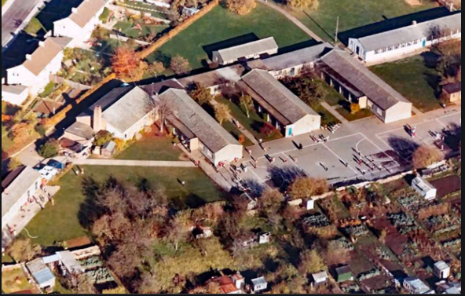
If you could add one thing to our playground what would it be and why?
Find out from everyone in your home, what they think the best thing about Corsham is. Do you agree with each other or not?

