This term you could:
Draw a map of the part of Corsham you live in (or your town if you don’t live in Corsham). Label the places that are important to you.
Sketch one of the older buildings in Corsham (or your town), remember what you learnt about texture before half term.
Go for a sound walk. Maybe take a notebook with you and write down all the sounds you hear as you pause along the way.
Create a Venn diagram like the one below, as this term, we will be talking about how we keep ourselves clean, (personal hygiene)
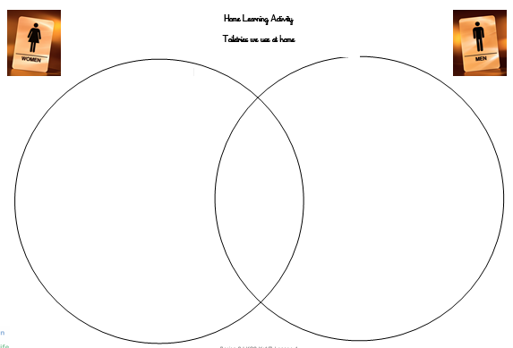
Research how wool is made-Corsham used to be a wool producing market town. Create a fact file of what you learn.
Use recycled materials, cardboard boxes, foil etc to make your own model of an historic building in Corsham

