Local History – Changes in Living Memory | Where do I come from?
- What changes have happened since you were born?
- What is a timeline?
- How could you order events/objects on a timeline?
- How could you use the words: past, present, older and newer to describe things on a timeline?
- What questions could you ask about the past?
- How could you find the answers?
- How could you look at or use evidence to ask and answer questions?
- What was it like for people?
- What happened?
- How long ago?

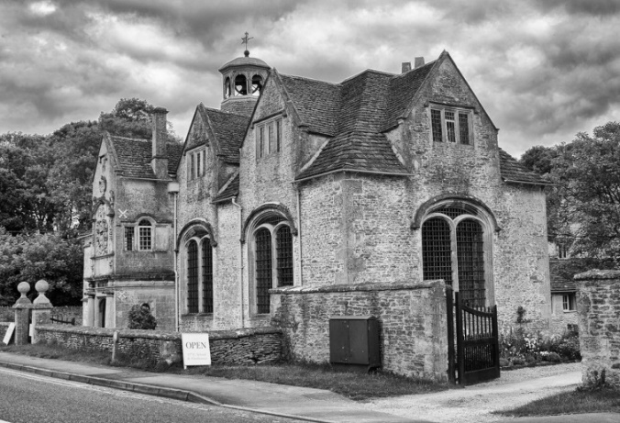

Related Milestones:
History M1:
• Recount changes that have occurred in their own lives. • Place events and artefacts in order on a time line. • Label time lines with words or phrases such as: past, present, older and newer. • Observe or handle evidence to ask questions and find answers to questions about the past. • Ask questions such as: What was it like for people? What happened? How long ago?

