Spring 2 Chatter Topics for
Fox Class

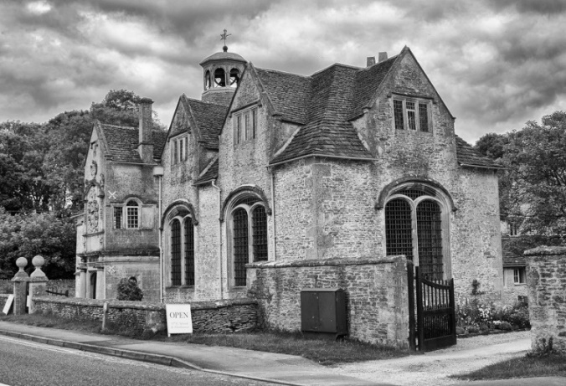

- What are your favourite places in Corsham and why?
- How have you changed?
- What was school like in the past? (ask a grandparent or relative)
- How has school changed? (tell a grandparent or relative)
- Would you prefer to be a child in the past or present? Why?
- What questions could you ask someone to find out about the past?

