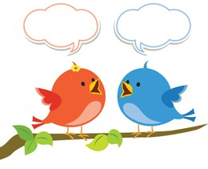
Mason Class Chatter topics

- What games did children play in the 1970s?
- What did children do in the 1970s?
- What changes happened in this decade?
- What was the Silver Jubilee and how was it celebrated?
- What transport was available?
- What special events took place in the 1970s?
- What was the fashion like?
- What were bellbottoms and platform shoes?
- What music did people listen to?
10. What was invented in the 70s?

