This term you could:
Interview someone you know who was alive in the 70s. What can they remember?
Create a spring picture, can you include images of the first signs of spring?
Listen to a piece of classical music, what can you find out about the composer? How does the music make you feel?
Find out about what fashions were popular in the 70s can you draw a picture of yourself wearing that style of clothing.
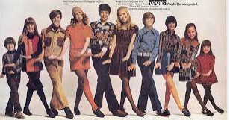
Look at this picture of a child’s bedroom from the 70s. What is the same/different from your bedroom?
