Home learning in Fox

In order to help your child learn, we encourage you to read with your child daily. This is to practise reading skills, comprehension and reading for pleasure. We would like you to spend time supporting your child to learn to read and spell the statutory words for Year 1. You could concentrate on 5 of these at a time. These are available on our website. Please ask your child about the maths that they are completing in class and practise number bonds to 10.
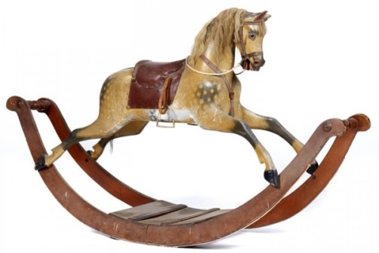

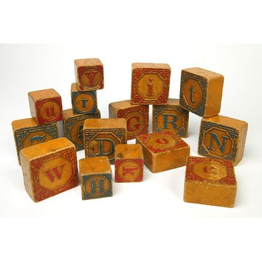

In addition to this we have some optional home learning linked to our big question this term, which is ‘what did children play with in the 1890’s?’ If you would like to help your child with our topic this term below are some ideas.

- Create an outdoor game for children in 1890 to play
- Make a 3D toy from Victorian times
- Draw a picture of a Victorian toy and describe how they are different from today’s toys
- Given verbal instructions how to play your outdoor game you have created
- Write a set of instructions of how to play with a Victorian toy or modern toy

