Music and Textiles | What did children play with in the 1890s?
- How could you join materials together?
- How could you use plaiting, weaving and printing to create patterns on materials?
- How could you shape materials using templates?
- How could you make your art ideas better?
- How could you make your model move?
- How could you describe music, using the vocabulary: beat, pitch, timbre and dynamics?
- How could you make up your own piece of music, using: long and short, high and low, quiet and loud sounds?
- How could you sequence sounds to create an effect?
- What symbols could you use to write your piece of music down?
- How could you use your written music to help you play?
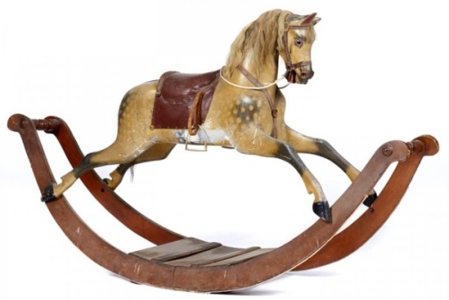

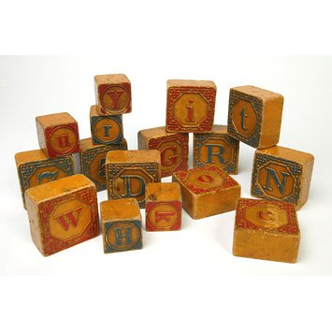

Related Milestones:
Art M1:
To develop ideas • Explore different methods and materials as ideas develop
TEXTILES- TECHNIQUES • Use plaiting. • Use dip dye techniques. • Use weaving to create a pattern. • Join materials using glue and/or a stitch.
Music M1:
To perform • Take part in singing, accurately following the melody. • Follow instructions on how and when to sing or play an instrument. • Make and control long and short sounds, using voice and instruments. • Imitate changes in pitch.
To describe music • Identify the beat of a tune. • Recognise changes in timbre, dynamics and pitch.
To compose music • Create a sequence of long and short sounds. • Clap rhythms. • Create a mixture of different sounds (long and short, loud and quiet, high and low). • Choose sounds to create an effect. • Sequence sounds to create an overall effect. • Create short, musical patterns. • Create short, rhythmic phrases.
To transcribe • Use symbols to represent a composition and use them to help with a performance.
DT M1:
Textiles • Shape textiles using templates. • Join textiles using running stitch. • Colour and decorate textiles using a number of techniques (such as dyeing, adding sequins or printing).

