Spring 1
What was life like in the 1920s?
Chatter Topics for
Brunel Class

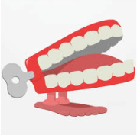
Chatter topic 1: Look at this photo from the 1920s. What is the same and what is different?
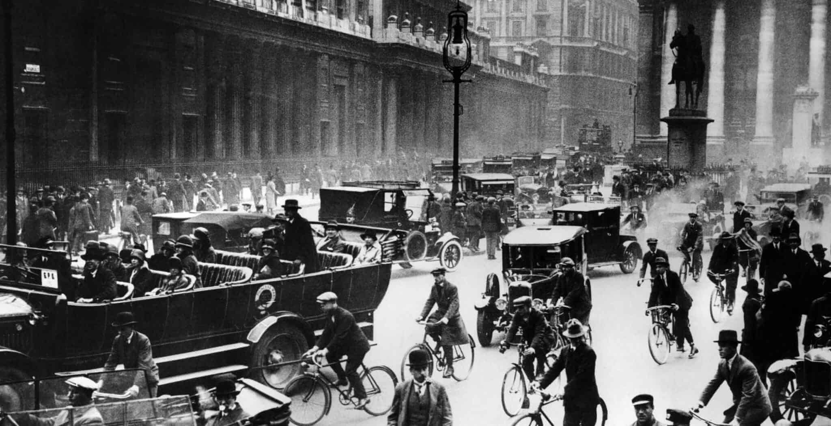
Chatter topic 2: Do you think you would have liked to have lived in the 1920s? Can you explain why?
Chatter topic 3: People really lived life to the full in the 1920s and there was lots of interest in new foods, fashions, entertainment and music. How would you spend the perfect day, living life to the full? Where would you go, what would you do and what would you eat?
Chatter topic 4: Jazz music became really popular in the 1920s. Use this link to listen to a piece of jazz music by Louis Armstrong. How does it make you feel? What instruments can you see and hear being played? (This link is from You Tube so make sure an adult is supervising when you listen to it).

https://www.youtube.com/watch?v=kky19Z32Oog

