Spring 1 Chatter Topics for
Fox Class

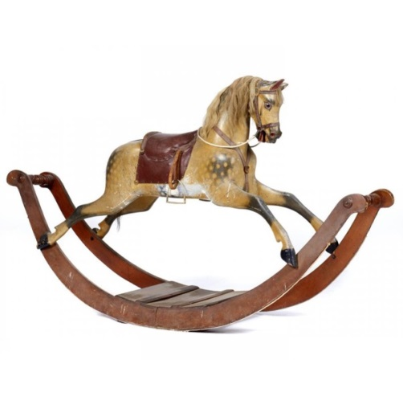

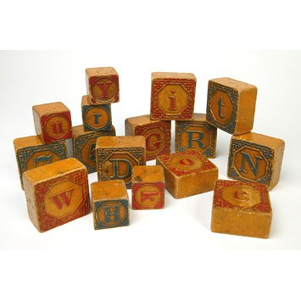

- What are your favourite toys and why?
- How can you tell if a toy is an old toy or a new toy?
- What materials are Victorian toys made from?
- What materials are your toys made from?
- How can you make a moving toy?
- Would you prefer to be a child in 1890 or 2020? Why?
- Can you give someone instructions how to play with your favourite toy?

