Spring 3
Chatter Topics for
Turner Class
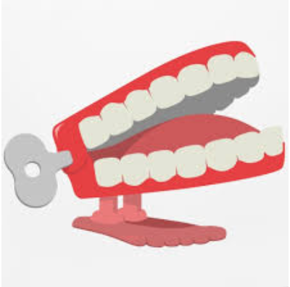
Chatter topic 1:
What famous artists in fashion, art and music were around in the 1960’s
Chatter topic 2:
What is a biography- have you read any? Chatter topic 3:
Did you know that a ring pull can was invented in the 1960’s? What else was invented during this time?

